Title/Author: *Stellaluna* by Janell Cannon

Suggested Time to Spend: 5 Days At least 20 minutes per day

Common Core grade-level ELA/Literacy Standards: RL.K. 1, RL.K.3, RL.K.4, RL.K.7; W.K.2, W.K.8, SL.K.1, SL.K.2, SL.K.5, SL.K.6, L.K.4

Lesson Objective:

Students will listen to a beautifully illustrated picture book read aloud and use literacy skills (reading, writing, discussion and listening), with attention to vocabulary and illustrations, to understand the central message of this picture book.

Teacher Instructions

**Before the Lesson**

1. Read the Big Ideas and Key Understandings and the Synopsis below. **Please do not read this to the students**. This is a description to help you prepare to teach the book and be clear about what you want your children to take away from the work.

Big Ideas/Key Understandings/Focusing Question:

What does Stellaluna learn about herself and her bird friends when she loses her mother? Stellaluna learns that she can make friends with birds who are different from her, and she learns that she can use her “bat” instincts to help her friends.

What is this story trying to teach us? Even though we have many differences, we can still be friends and learn from one another.

Synopsis

In this story, a baby bat separated from her mother is raised by a mother bird, on the condition that she acts as birds do: sleep at night, don't hang upside down, and eat worms and insects. Though she doesn't like behaving in this way, Stellaluna agrees and tries to prove she fits in with the birds. When she meets a group of bats one day, Stellaluna is reunited with her mother, who teaches her how bats are supposed to behave. Stellaluna tries to show her bird friends how to be bats, but realizes that they are better at just being birds, much as she is better at being a bat. Stellaluna uses her understanding of the birds to recognize when they are in trouble, and uses her bat strengths to save her friends when they attempt to fly at night. Despite their differences, Stellaluna and the baby birds remain great friends.

1. Go to the last page of the lesson and review “What Makes this Read-Aloud Complex.” This was created for you as part of the lesson and will give you guidance about what the lesson writers saw as the sources of complexity or key access points for this book. You will of course evaluate text complexity with your own students in mind, and make adjustments to the lesson pacing and even the suggested activities and questions.
2. Read the entire book, adding your own insights to the understandings identified. Also note the stopping points for the text-inspired questions and activities. *Hint: you may want to copy the questions vocabulary words and activities over onto sticky notes so they can be stuck to the right pages for each day’s questions and vocabulary work.*

The Lesson – Questions, Activities, and Tasks

|  |  |
| --- | --- |
| **Questions/Activities/Vocabulary/Tasks** | **Expected Outcome or Response (for each)** |
| FIRST READING:  Pull the students together in a close group or use a document camera so that all students can see the illustrations. Read aloud the entire book (or chapter) with minimal interruptions. Stop to provide word meanings or clarify only when you know the majority of your students will be confused.  <http://d33y93cfm0wb4z.cloudfront.net/slideshow/pdfs/bat_finger_puppet.pdf> This is the pattern for a finger puppet to be used during retells or vocabulary activities. | The goal here is for students to enjoy the book, both writing and pictures, and to experience it as a whole. This will give them some context and sense of completion before they dive into examining the parts of the book more carefully.  Students make bat puppets today to use during the story. |
| SECOND READING:  The goal of this reading is to have students practice the vocabulary by using total physical response with body movements, facial expressions, and their bat puppets.  During this reading, the teacher should elaborate with gestures and voice to build vocabulary concepts.  Create an anchor chart with words and drawings that will allow students to refer back to the words during multiple reads.  Model for students how Mother Bat talked and rocked Stellaluna and have students practice. Tell students that, “To croon means to hum or sing softly. “  Look at the picture under the document camera to show students what Mother Bat is doing. Have them “clutch” their Stellaluna puppet.  Show students that the owl is swooping out of the sky toward Mother Bat. (Model with your hand as the Owl and swoop toward the bat puppet.) Have students show the motions as you reread the sentence.  Show students with your hand and puppet how Mother Bat tries to escape by dodging the owl.  Play video clip from YouTube so students can hear the shriek of bats. <http://www.youtube.com/watch?v=7X-6_4WBdZs>  Remember the word clutched means to hold onto something tightly. Have students clutch their bat  Babbling means to talk too much.  pg. 7 Stellaluna quickly clambered from the nest and hung out of sight below it. What does it mean to “clamber”?  p. 9 Reread third paragraph: “Finally, though the little bat could bear it no longer. She climbed into the nest, closed her eyes, and opened her mouth. PLOP! In dropped a big green grasshopper.” When the author says, ‘the little bat could bear it no longer,’ it means she couldn’t stand it any longer. What couldn’t she bear?”    p. 17 Gracefully—model “gracefully” by teacher walking across  the floor. Show not gracefully or also known as clumsy. Then have students show “gracefully” demonstrating walking around in a circle group.  p. 20 Look at the pictures to determine that she is not landing gracefully. She is embarrassed.  Why is Stellaluna embarrassed?  P. 23 anxious The three anxious birds went home without her. To be anxious means that you are worried or upset about something. What are the birds anxious about?  On page 27, “You are hanging by your thumbs, so that makes you upside down!” the creature said. A creature is an animal that is strange. What animal does the author call a creature?  p. 29 Draw students’ attention to the beginning of the story when the Mama Bat battles the owl: “Sniffing Stellaluna’s fur she whispered, You are my baby.” Sniffling is when you breathe repeatedly through your nose.  Show students what sniffling is, then have them sniffle also.  p. 31 “You escaped the owl?” cried Stellaluna.  Have students put their bat under their legs and make the bat escape.  Escape means to get away from a dangerous place or situation.  “You survived ?” Survived means to remain alive  p. 39 When the author says, “I must rescue them!” What does Stellaluna have to do? Why does she have to rescue them?    “Neither can I,” howled Flitter. Howled means to make a long, loud cry that sounds sad. Why does Flitter howl?  She lifted them to a tree, and the birds grasped a branch. Grasped means to take and hold something firmly. Why is it important to grasp the branch?    p. 41 “We’re safe,” said Stellaluna. Then she sighed. “I wish you could see in the dark, too.”  A sigh is when you breathe in and out and make a long sound, especially because you are bored, disappointed, or tired. Why does the author have Stellaluna sigh when she is hanging with her friends?  “They perched in silence for a long time.”  Perch means to sit or stand on the edge of something  “How can we be so different and feel so much alike?” mused Flitter. Muse means to think about something for a long time.  “I think this is quite a mystery,” Flap chirped.  A mystery is something that people do not understand or can’t explain because they don’t know enough about it.  Why does the author want you to think about this mystery?  Tomorrow when we read the story again and discuss how Stellaluna and her friends are alike and different, we can help solve this mystery. | p. 2. Crooned “I’ll name you Stellaluna,” she crooned.  p. 2 Clutched . . . “Mother Bat would carry Stellaluna clutches to her breast as she flew out . . .”  p. 3 Swooped, dodged, shrieking  p. 5 …she clutched the thin branch, trembling with cold and fear.  p.7 The baby birds are babbling about Stellaluna.  Clambered means to climb or crawl.  She can no longer bear being hungry, so she allows the mother bird to feed her a big green grasshopper!  Students practice clumsy.  Embarrassed means feeling nervous and uncomfortable and worrying about what people think of you. For example, if you had to sing in front of a lot of people you may feel embarrassed if you messed up.  Stellaluna is embarrassed because she cannot land gracefully on the tree branch, the way the birds can.  They are worried about Stellaluna because she is outside at night all by herself. Since she is their friend, they are worried that something might happen to her, but they have to leave her in order to stay safe themselves.  It’s a bat. Show students the illustration on page 28 of Stellaluna and the creature.  Stellaluna has to save the birds from a situation of danger or harm.  They are going to crash because they can’t see at night, and they can’t see in the dark.  They need to hold tightly so they don’t fall because they can’t see in the dark.  Stellaluna is tired. She is also disappointed, because she says, “I wish you could see in the dark, too.”  The author wants you to think about the mystery so that you can learn something about the birds and bats. She also wants you to think about the reasons they feel this way about each other. |
| THIRD READING: Focus on specific sections of text to understand ---What does Stellaluna learn from the birds?  Begin t-chart focusing on the things birds do.  Listen to find one more thing that Stellaluna learns to do like the birds. Turn and talk to your partner using the following language frame:  Partner A : Another thing she learns to do like the birds is…..  Partner B: Stellaluna also learned to do ……. Like the birds.  (Reread the whole book to complete left side of t-chart.  **What can birds do? What can bats do?**  Reread page 2. What does Mother Bat do with Stellaluna every night?  Reread page 3. The author tells us what type of food bats eat. What do they eat?  How does the picture on page 8 help you to understand what is happening in the story?  Reread page 9. What are some things Stellaluna learns to do after she falls into the birds’ nest?  After reading page 11 ask students, what is one of the bat ways that Stellaluna did not change?  The curious baby birds were wondering why Stellaluna was hanging by her feet. What did those curious birds do?  Reread page 27. What is the strange creature that tells Stellaluna she is hanging upside down?  Reread pages 27-38. How does Stellaluna find out what bats are supposed to do?  On the right hand side of the t-chart, teacher will record things that bats do.  Students use a language frame to share what bats do:  Partner A: One thing bats can do is_______________.  Partner B: Another thing bats can do is ____________.  How does Stellaluna feel about being a bat now?  Listen to this part of the story to find out. Raise your puppet when you hear something in the story that shows how Stellaluna feels. Teacher reads pages 35-37  **Finish reading the story.**  What happens to Stellaluna’s friends?  How does Stellaluna use her abilities as a bat to rescue them?  Stellaluna says, “But we’re friends and that’s a fact.”  How do the animals feel about their lives? | She clutches Stellaluna while searching for food every night.  Bats eat ripe fruit.  Students should be able to respond that Stellaluna is in the birds’ nest. Her mom is lost. There are three other birds in the nest.  Teacher models writing on the chart things that the birds do.  Stayed awake all day, slept at night, ate bugs, land on branches gracefully with their feet.  She liked to hang by her feet.  The baby birds hung by their feet to try it out.  Students turn and tell their shoulder partner: “It’s a BAT!”  Her mother and the other bats tell her and show her how bats act.  Teacher models writing on the chart things that the bats do.  Student responses can be…..  Hang upside down, fly at night, eat fruit, can see everything at night  Students hold up their puppets when they hear phrases:  -“I’ll never eat another bug as long as I live,” cheered Stellaluna  as she stuffed herself full.  --“Wait until dark,” Stellaluna said excitedly.  Students use their puppets to act out the final stages of the story when the birds try to fly from the tree with Stellaluna, and cannot see where they are going. They continue showing with their puppets what Stellaluna must do to save her friends.  The friends know that they are different. They are glad that they can do some things together that are the same. They like knowing that their feelings are alike. Being friends is a FACT. |

FINAL DAY WITH THE BOOK - Culminating Task

* Using a story frame, write about one thing that is the same about the birds and Stellaluna. Write about something that is different. Tell why Stellaluna and the birds are special friends. Draw a picture of Stellaluna and the birds together. Based on what you read in Stellaluna, what did Stellaluna and the bats learn about each other?
* See the sample answer on the last page of this document.

Vocabulary

|  |  |
| --- | --- |
| **These words merit less time and attention**  (They are concrete and easy to explain, or describe events/  processes/ideas/concepts/experiences that are familiar to your students ) | **These words merit more time and attention**  (They are abstract, have multiple meanings, and/or are a part  of a large family of words with related meanings. These words are likely to describe events, ideas, processes or experiences that most of your student will be unfamiliar with) |
| Page 2 - **sultry** – weather that is hot with air that feels wet  Page 3 - **mango**– a sweet tropical fruit with a yellow red peel  Page 29-**sniffing**-breathe in air noisily through your nose in order to smell something  Page 31-**escaped**-getting away from a dangerous situation  Page 39-**howled**-to make a long, loud cry because you are unhappy, angry, or in pain.  Page 39-**shrieked**-make a very high, loud sound, especially because you are afraid, angry, excited, or in pain  Page 39-**grasped**-to take and hold something firmly  Page 39- **limb**-a large branch of a tree  Page 41-**sighed**-to breathe in and out making a long sound especially because you are disappointed, tired, etc.  Page 41-**perched**-to sit on top of something or on the edge of something | Page 7-**babble**-to talk quickly  Page 9-**bear**-tolerate the feelings that you have (Hunger)  Page 17-**gracefully**-moving in a smooth and attractive way  Page 21-**clumsy**-moving in an awkward way and tending to make things fall over  Page 23-**anxious**-worried about something  Page 31- **survived**-continue to live after an accident or illness  Page 39-**rescue**-to save someone from a dangerous situation  Page 41-**muse**-to say something in a way that shows you are thinking about it carefully  Page 41-**mystery**- a situation people do not understand or cannot explain because they don’t know enough about it |

Fun Extension Activities for this book and other useful Resources

* This is the pattern for a finger puppet to be used during retells or vocabulary activities.
  + <http://d33y93cfm0wb4z.cloudfront.net/slideshow/pdfs/bat_finger_puppet.pdf>
* Refer to Bat Notes on pages 42 and 43. Read the Bat Notes to students. Have students identify new information to add to the T-chart.
* This website provides an article and pictures to give more details about bats. Do a read aloud with students. The article provides guiding questions to ask students for each section.
  + <http://www.nwf.org/Kids/Ranger-Rick/Animals/Mammals/Fruit-Bats.aspx>
* Play the video for students after reading Stellaluna . Ask students what new information we have learned about bats and add it to the T-chart.
  + <http://video.nationalgeographic.com/video/kids/animals-pets-kids/mammals-kids/bat-flying-fox-kids/>
* Students can listen to the story being read at a listening center.
  + <https://www.schooltube.com/video/003196835a384365822b/>

Note to Teacher

* Remind students of parameters of partner talk, as necessary.
* If students are not accustomed to Language Frames, show them how to use the frames, and remind them of the importance of listening to what their partner says. These frames are useful for ELL or language impoverished students. Using a verbal response frame is not just giving students “chances to talk,” but boosting up academic language. A verbal response frame is more than “modeling” a correct response. It “unpacks” it for students and demonstrates a pattern that struggling students don’t tend to see themselves. A scaffolded response frame begins as a sentence starter, but adds support, enabling students to produce a competent verbal or written response in an appropriate register. By assigning partners and having precise tasks in which each partner will be engaged, all students are explicitly practicing academic language. Each student should always have a job. While Partner A is completing the language frame, Partner B should be listening, counting the ways, and adding one more reason. Students should complete the frames with two or three words introduced during the lesson.

**What Makes This Read-Aloud Complex?**

1. **Quantitative Measure**

Go to <http://www.lexile.com/> and enter the title of your read-aloud in the Quick Book Search in the upper right of home page. Most texts will have a Lexile measure in this database.

Most of the texts that we read aloud in K-2 should be in the 2-3 or 4-5 band, more complex than the students can read themselves.

2-3 band 420-820L

4-5 band 740-1010L

_550 Lexile_

1. **Qualitative Features**

Consider the four dimensions of text complexity below. For each dimension*, note specific examples from the text that make it more or less complex.

Theme: Differences, friendship

Even though Stellaluna and her bird friends are very different, they are able to appreciate each other and help each other in times of trouble. They are true friends.

Narrative

The story switches back and forth from dialogue to narrative, possibly confusing students.

Sentence structure is complex.

Pages 1-2 Oh, how Mother Bat loved her soft tiny baby.

Each night, Mother Bat would carry Stellaluna clutched to her breast as she flew out in search of food.

They hang by their feet and they fly at night and they eat the best food in the world,” Stellaluna explained….

Bats are mammals. Birds are a different species.

**Knowledge Demands**

**Structure**

**Language**

**Meaning/Purpose**

**3. Reader and Task Considerations**

What will challenge my students most in this text? What supports can I provide?

The vocabulary will be challenging for ELL and language impoverished children. We can provide Total Physical Response, and visual images for the vocabulary. Students will need background on scientific knowledge, which can be provided with photos, videos, and articles, as well as a companion text (BATS by Gail Gibbons).

How will this text help my students build knowledge about the world?

It will help students learn that we can be friends with people who are different than we are. They can also learn to use their own strengths to help others.

**4. Grade level**

What grade does this book best belong in? This book would be best used with Kindergarten or early first grade. These students need to hear and use a lot of vocabulary. They are learning to understand how other people communicate and act that are outside their family unit.

Culminating Activity

One thing that is the same about the birds and Stellaluna is _______________________ _______________________________________________________________________.

One thing that is different is that the birds _____________________________________ _______________________________________________________________________,

but Stellaluna ____________________________________________________________ _______________________________________________________________________.

Stellaluna and the birds learned that __________________________________________ _______________________________________________________________________.

Culminating Activity

One thing that is the same about the birds and Stellaluna is **that they both fly**________.

One thing that is different is that the birds **eat worms**____________________________,

but Stellaluna **eats fruit**____________________________________________________.

**C:\Documents and Settings\MCGARCA\Local Settings\Temporary Internet Files\Content.IE5\5AIMDWR1\MC900437481[1].wmf**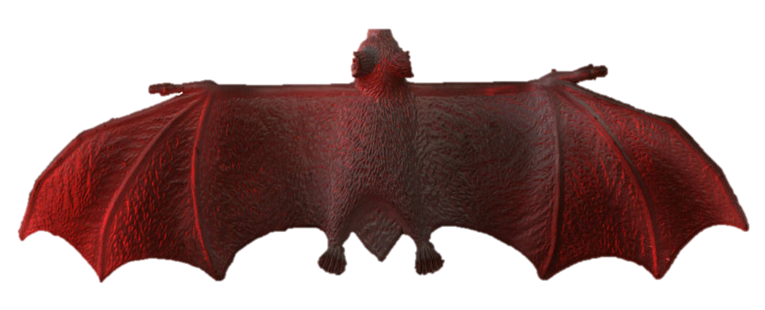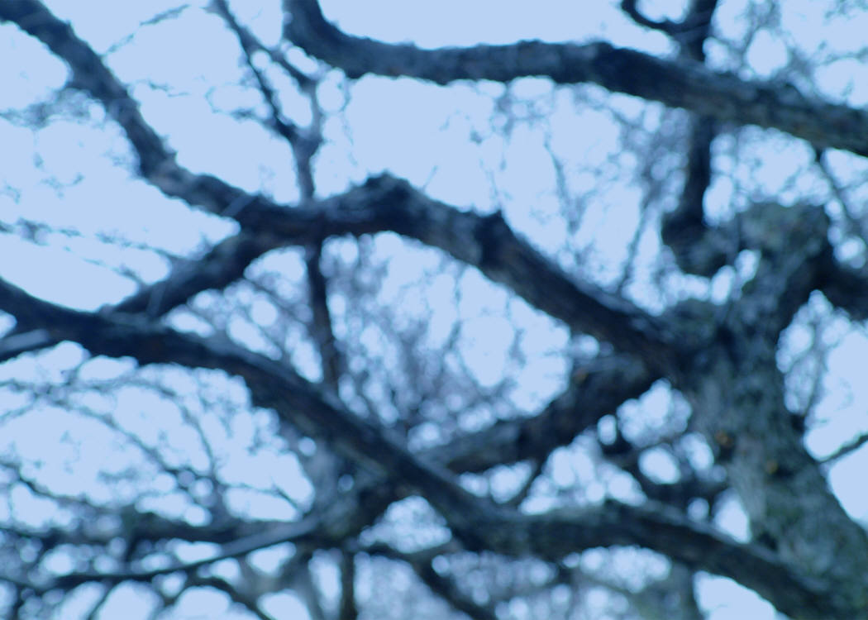 Stellaluna and the birds learned that **they can be different and feel so much alike. They are friends**