Title/Author: Around One Cactus by Anthony D. Fredericks
Suggested Time to Spend: 5 Days (Recommendation: five 30 minute sessions)
Common Core grade-level ELA/Literacy Standards: RI.2.1, RI.2.2, RI.2.3, RI.2.4, RI.2.6, RI.2.7; W.2.2, W.2.8, SL.2.1, SL.2.2, SL.2.5, SL.2.6; L.2.1, L.2.2 L.2.4
Lesson Objective:
Students will listen to an informational text read aloud and use literacy skills (reading, writing, discussion, and listening) to understand the how different creatures use the saguaro cactus to survive in the desert.

Teacher Instructions
Before the Lesson
- Read the Big Ideas and Key Understandings and the Synopsis below. Please do not read this to the students. This is a description to help you prepare to teach the book and be clear about what you want your children to take away from the work.
Big Ideas/Key Understandings/Focusing Question
The saguaro cactus is a haven for different creatures in the desert. Desert creatures need to find ways to survive in desert conditions.
Focus Question: How do creatures, who may or may not be friends, use the saguaro cactus to adapt to their special environment?

Synopsis
This is a literary text with a poetic structure which draws in information and content specific vocabulary focusing on the saguaro cactus in the Sonoran Desert. The author uses rhyme, repetition, and building text to explain how the saguaro cactus provides the means for some creatures to survive in desert conditions. (See standard RL2.4)ऀ
- Go to the last page of the lesson and review “What Makes this Read-Aloud Complex.” This was created for you as part of the lesson and will give you guidance about what the lesson writers saw as the sources of complexity or key access points for this book. You will of course evaluate text complexity with your own students in mind, and make adjustments to the lesson pacing and even the suggested activities and questions.
  - *For more information on the qualitative dimensions of text complexity, visit http://www.achievethecore.org/content/upload/Companion_to_Qualitative_Scale_Features_Explained.pdf
- Read the entire book, adding your own insights to the understandings identified. Also note the stopping points for the text-inspired questions and activities. Hint: you may want to copy the questions vocabulary words and activities over onto sticky notes so they can be stuck to the right pages for each day’s questions and vocabulary work.

The Lesson – Questions, Activities, and Tasks

Questions/Activities/Vocabulary/Tasks | Expected Outcome or Response (for each)
FIRST READING:  Pull the students together or use a document camera so that all can enjoy and use the illustrations. The illustrations play a key role in understanding some of the concepts and vocabulary in the story. Read aloud the entire book with minimal interruptions. Be sure to read the letter from the Western Diamondback Rattlesnake on the first page. Stop to provide word meanings or clarify only when you know the majority of your students will be confused. | The goal here is for students to enjoy the book, both writing and pictures, and to experience it as a whole. This will give them some context and sense of completion before they dive into examining the parts of the book more carefully.
SECOND READING:  As you read this time, you are going to focus on close reading and responding to text dependent questions to build meaning and knowledge about the saguaro cactus and what it provides for other desert species. Students may start reading parts of the text chorally, which should be encouraged.  Reread page 1  Questions:  Who is writing this letter? What is the purpose of the letter?  What does the snake say “adapt” means?  The snake states that some of the creatures are friends and some are not, but that’s OK. Why does he say that?  Reread page 3  Questions:  What do you notice about the way the author wrote this book?  Where does this story take place? What details from the illustrations and text support your claim?  Reread page 7  Questions:  What is the boy curious about?  Define arid as waterless and sunbaked. What might be some challenges for creatures living on this arid ground?  Reread page 8  Teacher Note: You may want to take the opportunity to build an understanding around nocturnal animals.  Questions:  Why does the boy leave?  Using the illustrations and details from the text, describe what happens when the boy leaves. (Teacher Note: The word “prey” may cause some confusion because of the way the author places it at the end of the sentence. They may think the animals woke to play and PRAY. Some clarification might be needed to distinguish between the two words.)  Reread Page 11  Questions:  How does the first creature use the cactus?  Reread Page 12  Questions:  How is the cactus a haven for the owl?  Why does the owl need perfect sight?  Reread Page 15  Questions:  What tower does the bat fly to? How is the cactus like a tower?  What is the bat spreading? (Note to teacher: you may need to build knowledge around pollination here.)  How does the cactus help the bat adapt to its environment?  How does the bat help the cactus survive?  How does the bat’s nose help it to spread the pollen?  Reread Page 16  Questions:  Who comes next?  What words does the author use to create a scary tone about the snake?  Why would a rattlesnake need to rely on the cactus to help it survive? (Teacher Note: you may need to help the students think about the animals they have already read about that might be food for the snake)  Reread Page 19  Questions:  Who comes next?  Why does the author use the word dance when describing the scorpion?  Reread Page 20  Questions:  Who is eyeing the scorpions?  Using evidence from the text and illustrations, describe why the foxes might be eyeing the scorpions.  Reread Page 22  Questions:  What is the gila monster looking for? What might be the gila monster’s snack?  Reread Page 24  Questions:  A survivor is someone or something that manages to live through a difficult situation. How are the animals living in a difficult situation? How does the cactus help the creatures survive in the desert?  How is the cactus like a guard? (Teacher Note: this question is meant to build an understanding around the metaphor before answering the next question.)  Explain in your own words the meaning of the last sentence: The spiny plant with its weathered face is a noble guard in this busy place. (Teacher Note: you may need to spend some time on vocabulary before students will be able to answer this question)  THIRD READING:  ***During the third reading, have the students read the following line chorally with you each time it is encountered: Beside the cactus tall and grand, a haven for creatures in a waterless land.***  Reread Page 2  Questions:  Personification is when an author gives human traits to something that is not human. Listen carefully as I reread the page for an example of personification. What example of personification did you find?  Why does the author use gripping?  Reread Page 7  Questions:  Listen carefully as I reread for another example of personification. What example of personification did you hear?  Reread Page 19  Questions:  Listen carefully as I reread for another example of personification. What example of personification did you hear?  Teacher Note: With student help, collect the last words of the lines and write them on the board or a piece of chart paper (tails, trails, teeth, beneath, tower, flower, sight, night, nest, rest, grand, land). Sometimes authors will put important words at the end of lines in poetry. How do these words help you understand this story? Talk to your partner. (Follow with whole group discussion) | The Western Diamondback Rattlesnake is writing the letter. The snake is writing the letter to introduce the reader to the desert environment and to get us interested in the desert. The snake uses the words “amazing” and “unique” to pique our interest.  The snake says that adapt means to survive and reproduce. He says that it also means that there are many kinds of neighbors who like to live in the same area.  It’s OK that they may not be friends, because the animals have adapted to their special environment in order to survive and reproduce. This means they may need to live next to enemies.  This is poetry. There is rhyme, rhythm, and patterning.  This story takes place in the desert. The author says it’s a desert and describes it as sun-baked, a waterless land, with a cactus and dunes.  The boy is wondering who could be living on this arid ground.  Answers may vary, but students should talk about finding basic needs such as shelter, water, and food which may be scarce due to the environment.  He doesn’t see any creatures because they are resting far from sight. It’s getting dark, and he probably needs to go home.  The creatures wake up to play and hunt (prey). The rabbit watches the boy leave.  The rat builds a cozy nest to shelter her babies.  It builds a nest in it. The babies are safe from predators.  The owl hunts at night and needs perfect sight to see the prey.  The bat flies to the cactus, which is the tower. The cactus is like a tower because it stands tall in the desert.  The bat is spreading pollen from flower to flower on the cactus.  The cactus provides food for the bat.  It helps it pollinate flowers.  The bat has a long nose, which allows it to reach deep inside the flower to where the pollen is.  The rattlesnake comes next.  The author uses words like deadly and slip-slides.  The rattlesnake comes to the cactus to hunt for other animals that depend on the cactus to survive (like the rat).  Some scorpions come next.  The author uses dance to describe the way the scorpions walk along the trails.  A den of foxes is eyeing the scorpions.  The fox is licking its lips as if it’s hungry. He might want to eat the scorpion.  The gila monster is looking for a snack. It might also want to eat the scorpions.  The animals are trying to find food and shelter in the desert environment. They may have to live next to creatures they are enemies with. They may have to find food at night. The cactus provides shelter, protection, and food for creatures in the desert. (examples: the rat and owl use the cactus for shelter, the bat drinks the pollen from the flowers)  A guard is someone or something that protects others. The cactus provides protection for the creatures in the desert.  (Answers may vary) This sentence describes the prickly cactus that has been worn down by the weather as a protector of the animals in the desert.  “bushes gripping ancient ledges”  To show how the bush has to survive by hanging on to the ledge so as to not be blown away by the wind.  The prickly cactus with arms raised high  Some scorpions with stinging tails dance along on unseen trails.  Students should discuss how each word relates to or describes the creatures and the cactus. Examples: tower describes the tall cactus, flower describes the food for the bat, teeth describes the dangerous rattlesnake, etc.
Reread Page 24  Questions:  What does the author mean when he states that the survivors are sheltered and harbored by the cactus?  Reread the line from the previous page: Beside the cactus tall and grand, a haven for creatures in a waterless land. Using details from the text, what do you think a haven might be? How is the cactus like a haven?  FOURTH READING:  During this last reread, students will create a t-chart of the creatures in the story and how they use the cactus. This will serve as their graphic organizer for the culminating task. Be sure to stop during this read as needed for students to complete their chart. Model with a class chart as needed. | The author means that the cactus keeps the survivors safe by providing food and shelter.  A haven is a safe place. The cactus is a haven because it keeps the creatures in the desert safe and protected by providing food and shelter.  Example:
  Creatures | Cactus
  rat | builds nest for babies
  owl | lives high up to hunt
  bat | drinks nectar from flowers

FINAL DAY WITH THE BOOK (Day 5)- Culminating Task
- Discuss the focus question whole group (students should be using their t-charts to organize their thoughts for writing): How do creatures, who may or may not be friends, use the saguaro cactus to adapt to their special environment?
  - Sample answer: The saguaro cactus helps the creatures adapt to the desert environment. The rat builds its nest at the bottom of the cactus to shelter its babies. The tiny owl lives high up on the cactus which helps it see its prey at night. The long-nosed bat drinks nectar from the cactus flowers. Other animals live near the cactus such as rattlesnakes, scorpions, and foxes. Even though some are enemies, they still gather at the cactus to meet their survival needs. The gila monster comes to the cactus to hunt for a snack. The saguaro cactus helps these creatures survive in the desert.
- Provide students with the writing prompt and scaffold as necessary for your class.

Vocabulary
These words merit less time and attention  (They are concrete and easy to explain, or describe events/  processes/ideas/concepts/experiences that are familiar to your students ) | These words merit more time and attention  (They are abstract, have multiple meanings, and/or are a part  of a large family of words with related meanings. These words are likely to describe events, ideas, processes or experiences that most of your student will be unfamiliar with)
Page [3] –dunes – a mound of sand formed by the wind  Page [3]- creatures - animals  Page [3]- majesty – impressive, dignity, beauty  Page [4] – prickly – covered in prickles  Page [4]- breeze- a gentle wind  Page [4] – arid – having little or no rain, dry, barren  Page [8]- critters - a living creature, animal  Page [16]- deadly - causing or able to cause death  Page [19]- unseen – not seen or noticed  Page [20]- eyeing - look at or watch closely | Page [1] – adapt – to change to match conditions  Page [3] –shifting- changing, especially unpredictably  Page [3] – edges –the outside limits of an object  Page [3] – ledges –a narrow horizontal surface projecting from cliff  Page [3] – gripping – to grab or hold tightly  Page [3]- ancient – belonging to the very distant past  Page [3] –grand – magnificent and imposing  Page [3] –waterless – lacking sufficient water or rainfall  Page [3]-haven – a place of safety or refuge  Page [4] -curious – eager to know or learn something  Page [8]- observed – noticed or perceived something  Page [8]-prey - hunt and kill for food  Page [11] - sheltered – protected from difficulties or bad weather  Page [15] - tower – a tall narrow building  Page [15] - pollen – a fine powdery substance produced by a plant  Page [16] – beneath – at a lower level or layer than  Page [24] – survivors –person remaining alive where others died  Page [24] – weathered – worn by long exposure to the air  Page [24] – spiny – full of or covered with prickles  Page [24] – harbored – give a home or shelter to  Pages [24] – noble guard - a protector with high moral principles

Fun Extension Activities for this book
- To further explore the language and concepts, create a reader’s theater around the text. Assign a small group of students to the different parts of the book (A tiny owl with perfect sight, who sleeps by day and hunts by night). Have the students create an illustration for the part and practice reading the lines chorally. Present the illustration and recite the lines during a reading of the reader’s theater.
- Create a picture of the cactus and the creatures from the text using the position words the author uses throughout the poem (beside, high above, above, upon, past, near). Students can use the blackline master of the cactus to start, or create their own. Then the students should draw the animals where they belong around the cactus according to the position words (A leaping rat builds a cozy nest, a sheltered place for her young to rest, beside the cactus tall and grand…)
- At the beginning of the text, there is a persuasive letter from the Western Diamondback Rattlesnake providing even more information about the desert while encouraging students to become interested in this environment. The students could then write a letter back to the Rattlesnake telling it everything they have learned about the desert. Or, they could write a letter persuading others to become more knowledgeable about the desert.
- At the end of the text, there are field notes to explore more detailed information about each creature featured in the text. This could be used for report writing or expert groups.
- This lesson was written to be paired with The Desert Giant, which provides more in depth information around the saguaro cactus. Consider using Around One Cactus first.
- Build additional knowledge around the saguaro cactus by watching these short videos:
  - http://www.bing.com/videos/search?q=saguaro+cactus+videos+for+kids&FORM=VIRE2#view=detail&mid=65C492CCD896832A5E0965C492CCD896832A5E09
  - http://www.bing.com/videos/search?q=saguaro+cactus+videos+for+kids&qs=AS&sk=&FORM=QBVR&pq=saguaro%20cactus%20video&sc=3-20&sp=1&qs=AS&sk=#view=detail&mid=6213D2797ABAF6E4B6856213D2797ABAF6E4B685
  - https://www.youtube.com/watch?v=NmTH6zsCs9Y ऀ

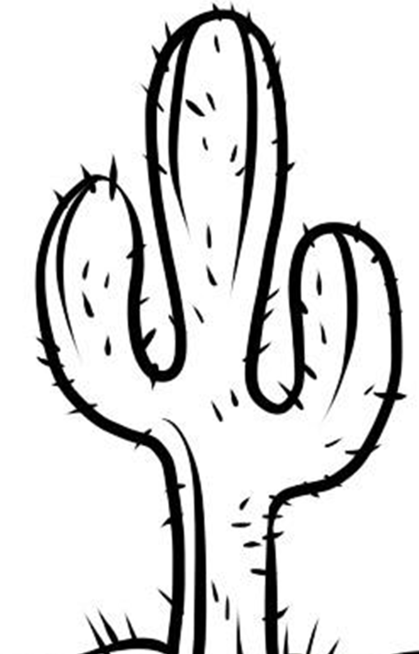
What Makes this Text Complex?

- Quantitative Measure
Go to http://www.lexile.com/ and enter the title of your text in the Quick Book Search in the upper right of home page. Most texts will have a Lexile measure in this database.

5.2
(Lexile level not available, DRA 38, Guided Reading P)

_____
2-3 band 420-820L
4-5 band 740-1010L
6-8 band 925-1185L
9-10 band 1050-1335L
11-CCR band 1185-1385L

- Qualitative Features
Consider the four dimensions of text complexity below. For each dimension*, note specific examples from the text that make it more or less complex.
In the arid desert, many types of animals use the giant saguaro cactus for survival.
A nonfiction text that uses poety and building text.

Text includes specific content vocabulary, diverse language, personification, complex sentence structures, rhyming, and repetition. “Here stands a cactus, tall and grand, a haven for creatures in a waterless land.”

Some students may need background information on desert environment and animals’ basic needs.

Meaning/Purpose
Structure

Language
Knowledge Demands

- Reader and Task Considerations
What will challenge my students most in this text? What supports can I provide?
- This text provides a lot of information, rich vocabulary, and complex sentences. Support using a graphic organizer (t-chart), repeated readings, reader’s theater, questions to clarify word meanings, time spent on syntax, and attention paid to illustrations.

How will this text help my students build knowledge about the world?
- The text will help students build background knowledge around the desert environment and animals in that environment. Students familiar with this content and vocabulary will have a basis for understanding more complex text they may encounter in the future.

- Grade level
What grade does this book best belong in? 2nd grade

